Modes of Music

Definition
# Source: AI Source: Provided by: [Data Path: Persons Table -> ID Column: 1, Name_En Column: Motasem Essam] -> From: [ChatGPT] on [10/26/2025]
Modes of music refer to the different scales or patterns of notes that form the foundation of a melody.
Each mode has its own unique sound, mood, and emotional effect.
In simpler terms:
A mode is a way of organizing the notes in music to create a certain feeling or atmosphere — happy, sad, calm, mysterious, etc.

Modes of Music (with Historical Development)

🎼 1. Natural / Primitive Modes
# Source: AI Source: Provided by: [Data Path: Persons Table -> ID Column: 1, Name_En Column: Motasem Essam] -> From: [ChatGPT] on [10/26/2025]
(Prehistoric Era – before 5000 BC)
- Description: The earliest form of musical sound organization used by prehistoric humans (like Neanderthals).
- Characteristics: Unstructured tones, natural pitches, simple rhythms, and vocal or flute-like sounds based on instinct.
- Example: Neanderthal bone flute sounds, primitive chanting.

🎼 2. Western (Greek / Church) Modes
# Source: AI Source: Provided by: [Data Path: Persons Table -> ID Column: 1, Name_En Column: Motasem Essam] -> From: [ChatGPT] on [10/26/2025]
(Ancient Greece → Medieval Europe)
These are the seven traditional modes used in Western classical and modern music.
They’re based on the white keys of a piano (C to C, D to D, etc.), but can start on any note.
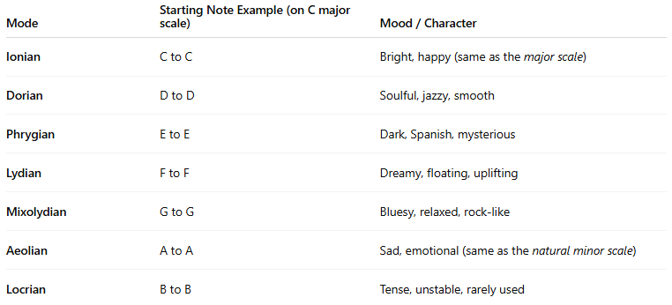
Mode | Starting Note Example (on C major scale) | Mood / Character
Ionian | C to C | Bright, happy (same as the major scale)
Dorian | D to D | Soulful, jazzy, smooth
Phrygian | E to E | Dark, Spanish, mysterious
Lydian | F to F | Dreamy, floating, uplifting
Mixolydian | G to G | Bluesy, relaxed, rock-like
Aeolian | A to A | Sad, emotional (same as the natural minor scale)
Locrian | B to B | Tense, unstable, rarely used

🌍 3. Indian Classical Modes (Ragas)
# Source: AI Source: Provided by: [Data Path: Persons Table -> ID Column: 1, Name_En Column: Motasem Essam] -> From: [ChatGPT] on [10/26/2025]
(Ancient India – over 2000 years ago)
In Indian music, Ragas are melodic frameworks or modes used to express specific moods, times of day, or seasons.
There are hundreds of ragas, but here are a few famous ones:

Raga Name | Mood / Time of Day
Raga Yaman | Peaceful, evening
Raga Bhairavi | Devotional, early morning
Raga Desh | Joyful, monsoon season
Raga Bhimpalasi | Romantic, afternoon
Raga Darbari Kanada | Serious, emotional, night

🏺 4. Middle Eastern Modes (Maqamat)
# Source: AI Source: Provided by: [Data Path: Persons Table -> ID Column: 1, Name_En Column: Motasem Essam] -> From: [ChatGPT] on [10/26/2025]
(Ancient Mesopotamia / Arabic Tradition)
In Arabic and Middle Eastern music, Maqam (plural: Maqamat) are modes that define the scale, melodic development, and emotional tone.

Maqam Name | Mood / Feel
Maqam Hijaz | Mysterious, spiritual
Maqam Rast | Balanced, noble
Maqam Bayati | Warm, expressive
Maqam Nahawand | Sad, emotional (similar to minor scale)
Maqam Kurd | Dark, reflective

🐉 5. East Asian Modes
# Source: AI Source: Provided by: [Data Path: Persons Table -> ID Column: 1, Name_En Column: Motasem Essam] -> From: [ChatGPT] on [10/26/2025]
(Ancient China, Japan, Korea)
Traditional East Asian music often uses pentatonic (5-note) scales as modes.

Culture | Mode / Scale Name | Mood / Character
Chinese | Gong, Shang, Jue, Zhi, Yu | Various emotional tones using 5-note systems
Japanese | In scale, Yo scale | Calm, meditative, or emotional
Korean | Pyeongjo, Gyemyeonjo | Peaceful or sorrowful tones

🎧 6. Modern / Contemporary Music Modes
# Source: AI Source: Provided by: [Data Path: Persons Table -> ID Column: 1, Name_En Column: Motasem Essam] -> From: [ChatGPT] on [10/26/2025]
(Renaissance → Today)
Modern composers and producers sometimes refer to modes more broadly as moods or tonal centers in genres like jazz, rock, and film scoring.
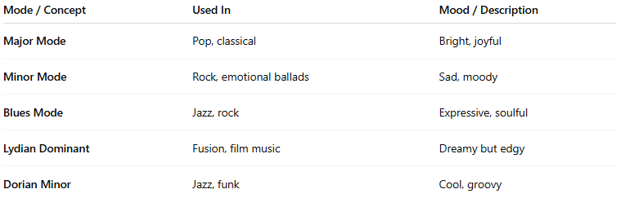
Mode / Concept | Used In | Mood / Description
Major Mode | Pop, classical | Bright, joyful
Minor Mode | Rock, emotional ballads | Sad, moody
Blues Mode | Jazz, rock | Expressive, soulful
Lydian Dominant | Fusion, film music | Dreamy but edgy
Dorian Minor | Jazz, funk | Cool, groovy

Examples of Modes
# Source: AI Source: Provided by: [Data Path: Persons Table -> ID Column: 1, Name_En Column: Motasem Essam] -> From: [ChatGPT] on [10/26/2025]
- Natural / Primitive Mode (Prehistoric Era)
→ Bone Flute Sounds — early human music made from natural pitches and vocalizations; raw, instinctive, and unstructured.
- Western Mode:
→ Dorian Mode — used in jazz and blues for its smooth, soulful sound.
- Indian Classical Mode (Raga):
→ Raga Yaman — peaceful and often played in the evening.
- Middle Eastern Mode (Maqam):
→ Maqam Hijaz — has a mysterious, spiritual feeling.
- East Asian Mode:
→ Yo Scale (Japanese) — creates a calm and gentle atmosphere.
- Modern / Contemporary Mode:
→ Blues Mode — expressive and emotional, common in jazz and rock music.

🧠 In Summary
# Source: AI Source: Provided by: [Data Path: Persons Table -> ID Column: 1, Name_En Column: Motasem Essam] -> From: [ChatGPT] on [10/26/2025]
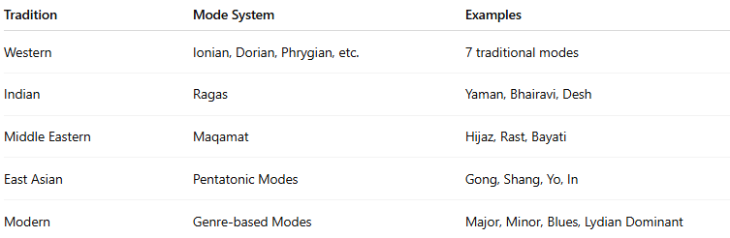
Tradition | Mode System | Examples
Western | Ionian, Dorian, Phrygian, etc. | 7 traditional modes
Indian | Ragas | Yaman, Bhairavi, Desh
Middle Eastern | Maqamat | Hijaz, Rast, Bayati
East Asian | Pentatonic Modes | Gong, Shang, Yo, In
Modern | Genre-based Modes | Major, Minor, Blues, Lydian Dominant

